**Statement of Goals:**

We want to make a game which will challenge us to make, and be enjoyable to play. Some of our goals that will make the experience more challenging for us include creating our own assets, enemy AI, and having random level generation. Our intended audience will be people who like roguelike games, but we also want this to be enjoyable for people at all levels of experience with games so the entire computer science department can have fun with it.

**Functional Description:**

This will be a roguelike game viewed in 2-dimensions from the top diagonally looking down. A roguelike game is one where the player must reset from the start upon death, and all their progress and the things they collect are lost. This means each new game the player starts will be referred to as a singular run, rather than a continuation of what they’ve done before.

The game will have a basic style of graphic design, so expect to be able to count the pixels in the art. Just like most games, when you launch the game you will encounter a main menu screen. We will have buttons to start a new game, go into options, get help, and exit the game (may implement a continue game button but this is optional in roguelikes as many of them do not have a save feature on purpose). When you go into options, you will be able to make choices about your video and audio. When you go into help, you will get a basic tutorial that helps you learn how to start playing the game and gives you some tips about progression.

When you start a new game, you will be launched into a hub zone where you can spend some currency that carries across runs. This currency might allow you to unlock new guns or abilities to use. This is so we have some form of permanent progression that isn’t tied to making the game easier, as roguelikes are intended to often be challenging. You also may be able to switch your beginning character in this hub zone to a separate one that has different beginning items or abilities. To begin a run, you will go to someplace in this hub world and indicate that you want to play, then you will be put into a loading screen as the level is generated. Each level you go into will have some configuration of rooms, possibly some bonus rooms where you can get items, and a boss room. We want them to be procedurally generated somewhat, so even if you replay a level the rooms will be in a different configuration each time. The player will go from room to room and fight any enemies that are encountered inside, and try to collect any items you can find, until you reach the boss room. Once you get to the boss room you will have to fight and defeat the boss to get to the next level, or beat the game.

At this point we would like every level to be themed around a sport, meaning enemies you encounter in that area will have some gear that is related to that sport, and the boss will be the same. We plan to have most of our weapons themed around sports as well, such as a melee weapon baseball bat or a ranged weapon hockey puck. The player will likely be moved in each direction with wasd, and attack in the direction the mouse cursor is pointing with mouse 1. Ideally, all of the sound and art in the game will be designed by us.

**User Interface:**

We will be creating our UI using tools within Unity

Main Screen:

Image created to be entered into UI

Play: Button to initiate new game and enter into state Character Selection Menu

Settings: Button to change certain settings within game

Help: Button to access game tutorial and other help

Exit: Exit button to leave application

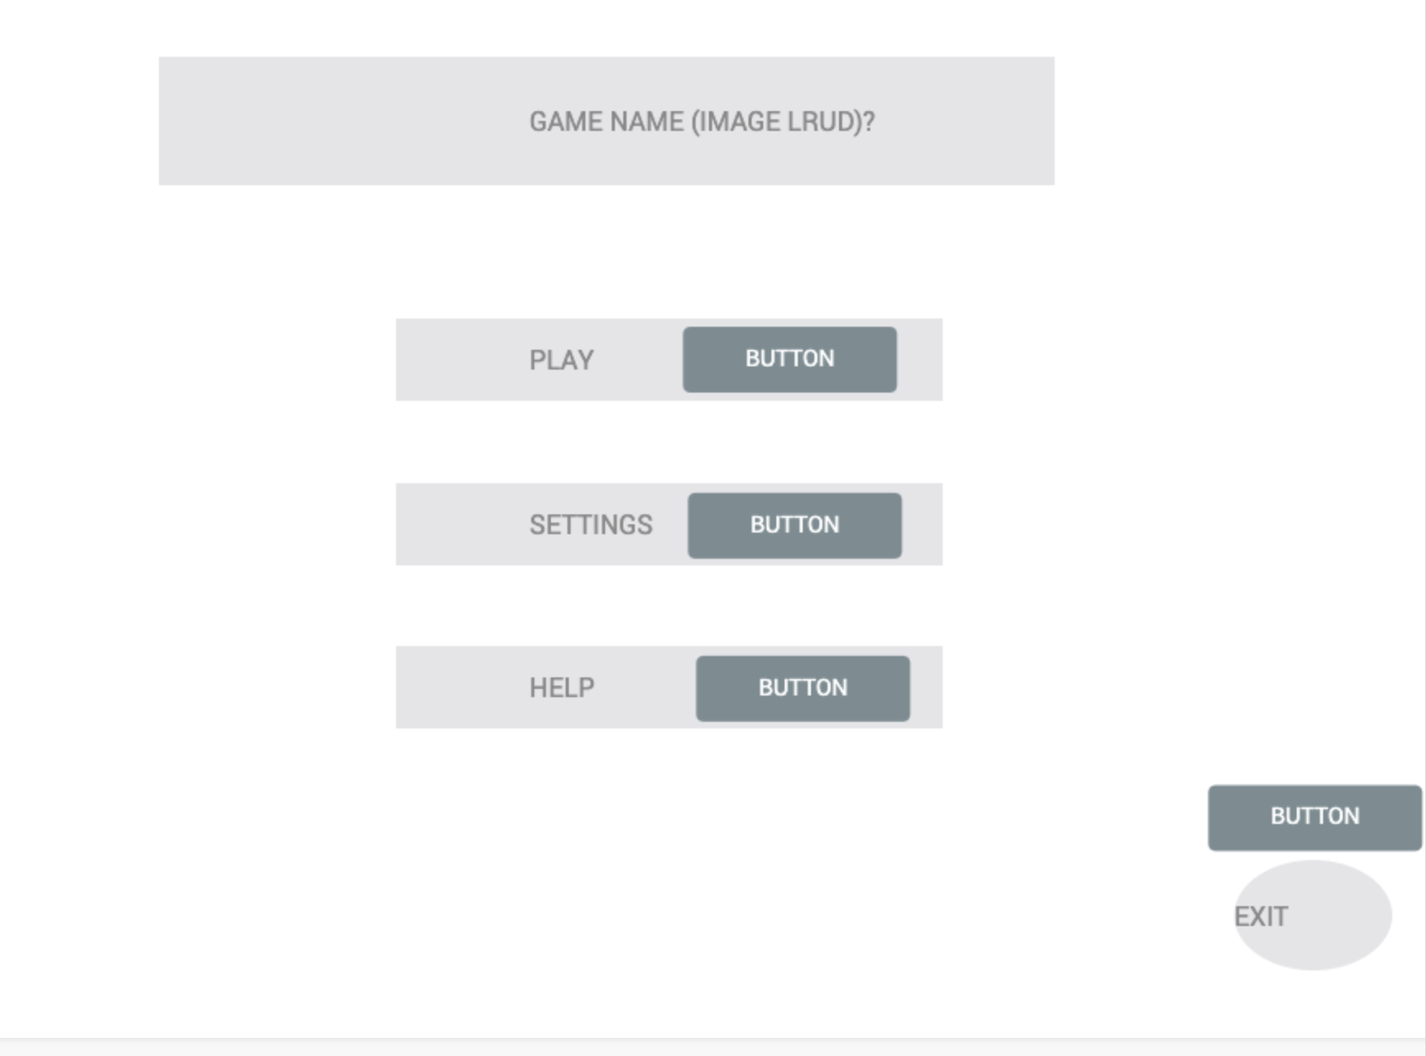

Character Selection Menu:

Images for each class available to the user in placeholder

Select Character: Button to select and deselect different available classes

Begin: Begin will be highlighted if able to click, must have a class selected

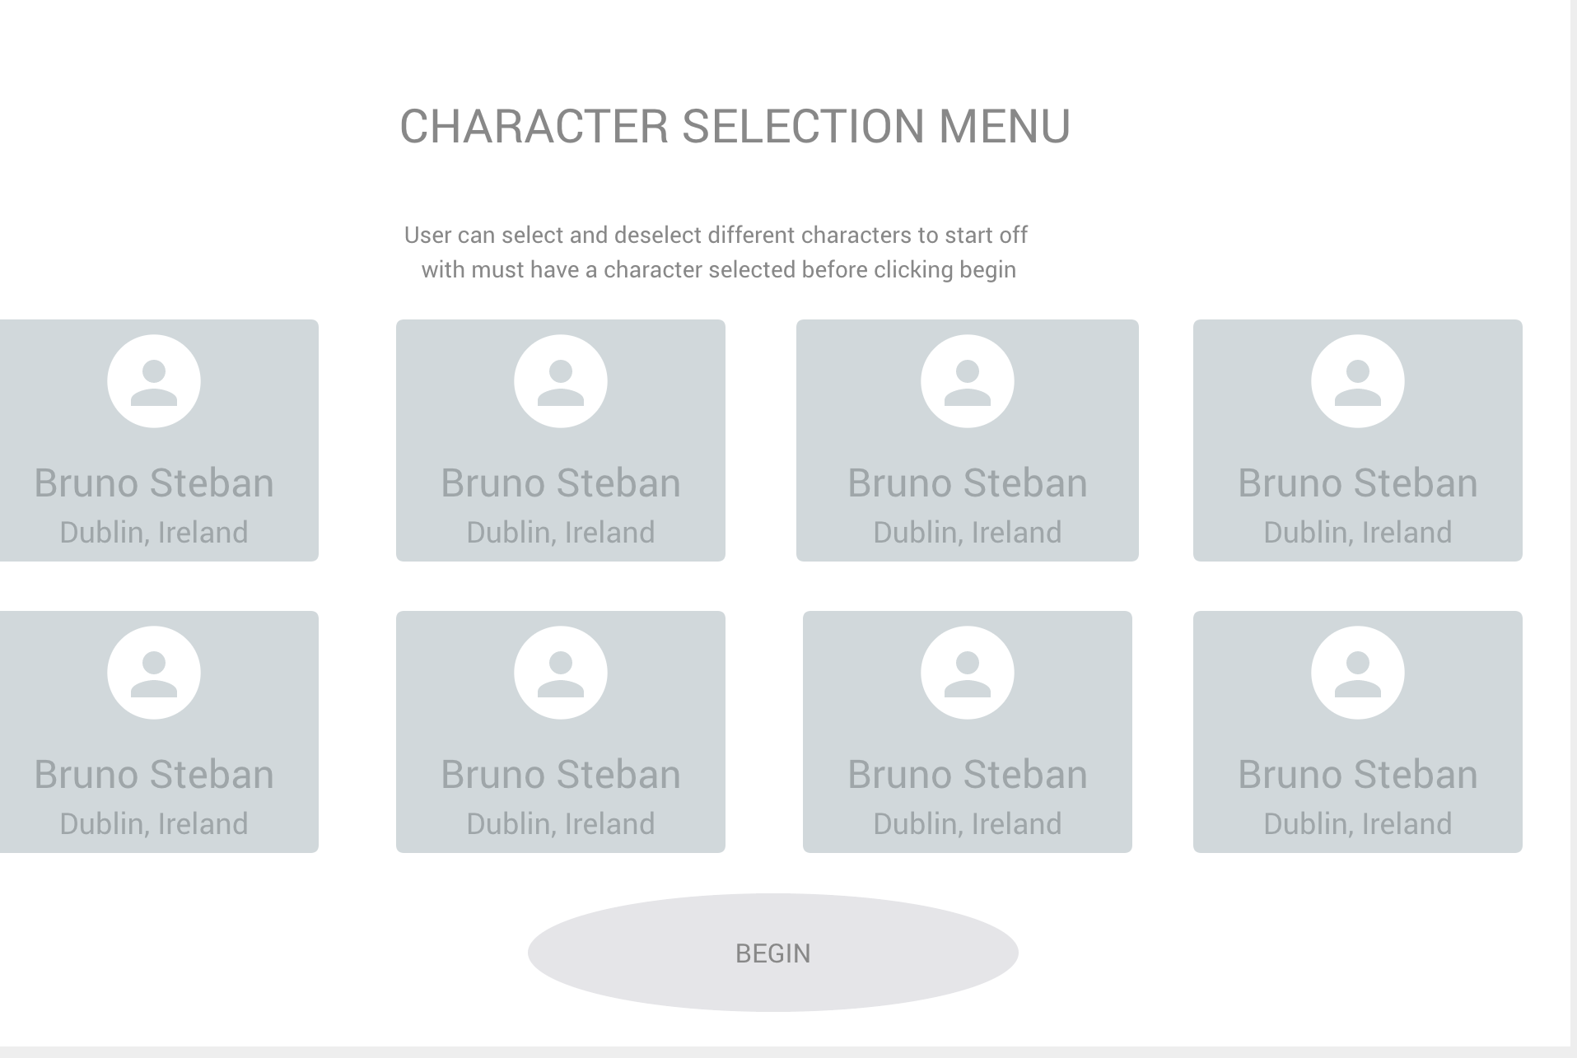

Settings:

User will be able to change various items to customize there in game experience

Graphics: edit resolution in game

Audio: change song playing, adjust in game volume

Difficulty: tweaks game mechanics to make game harder or easier

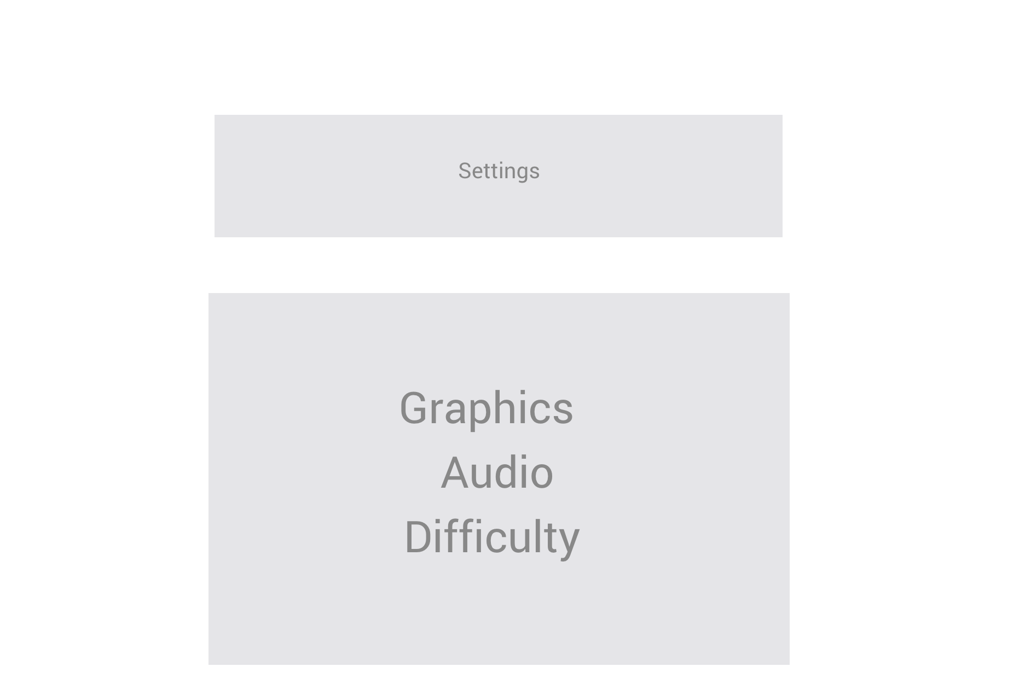

**Milestones:**

1. Finish design documents
   1. Need to get milestones finished
   2. Need to do preview video
   3. Need to do teaser video
2. Make sure we all have software necessary
   1. Get Unity Teams working for all of us for version control and collaboration features
      1. Unity Student Plan allows for up to 5 team members and is free
   2. Plan out art creation
      1. Use piskel to make sprites and animations
      2. codeandweb.com/sprite-sheet-maker to put together spritesheets quickly
   3. Plan out sound creation
      1. Music will be either created by AI using <https://ecrettmusic.com/play> or by us using the software BoscaCeoil to make it
      2. Sound effects will either be made from scratch by us, or generated by using https://sfxr.me/
   4. Using Trello for tracking of progress across roles
      1. Trello lets us individually update our long term progress so we can all see where we are at
3. Players and enemies can move and interact.
4. Get basic sprite sheets of enemies, characters and levels
5. UI works seamlessly
6. Have good sound effects including music.
7. At least one working level.
8. Competent AI
9. Procedural levels
10. Minimum goal: Complete the first level of our game, which will include procedurally generated level, AI enemies, and a final boss
11. Add detailed sprites, weapons, enemies, songs, etc.
12. Maximum goal: Complete art, sound, and coding for several levels beyond just one